Here I'm Waiting You, Dear
Here You Can Chat With Unreal Cutie Girl
If You Want You Can Find me By ID: 486283924
OR FIND ME BY NICK: venera3216361

FIND HERE
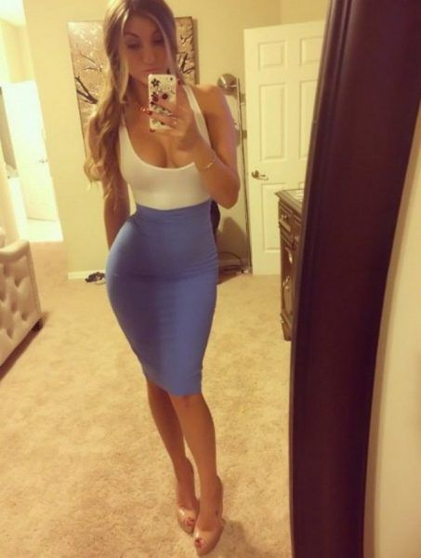
unsub here

