UNBELIEVABLE BEAUTIFUL GIRLS
I WANNA SHOW YOU MY BODY
Chat To Me NOW!
TRY NOW - jiji3957299

OPEN HERE NOW
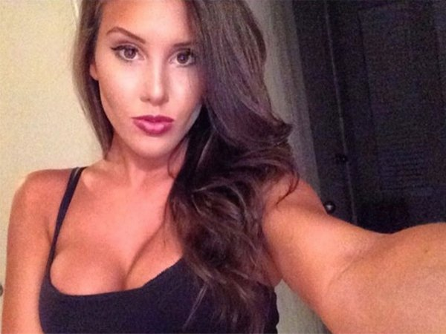
uns here

