UNBELIEVABLE BEAUTIFUL GIRLS
I WANNA SHOW YOU MY BODY
Chat To Me NOW!
TRY NOW - christi9223866

FIND NOW
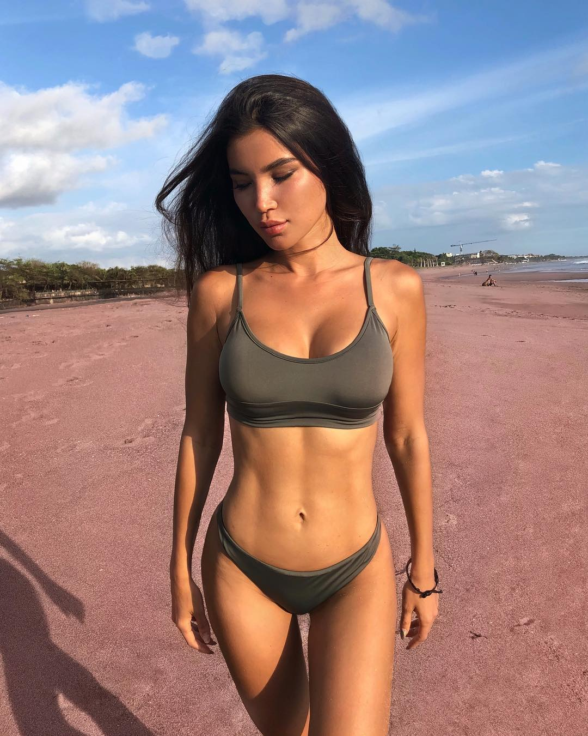
uns here

