UNBELIEVABLE BEAUTIFUL GIRLS
I WANNA SHOW YOU MY BODY
Chat To Me NOW!
TRY NOW - mia4533631

FIND HERE
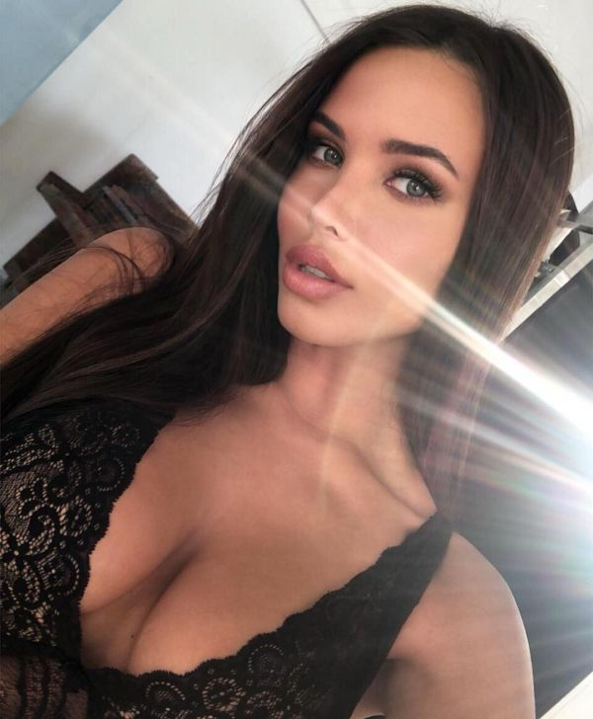
unsub now here

