UNBELIEVABLE BEAUTIFUL GIRLS
I WANNA SHOW YOU MY BODY
Chat To Me NOW!
TRY NOW - rud3914439

VIEW NOW
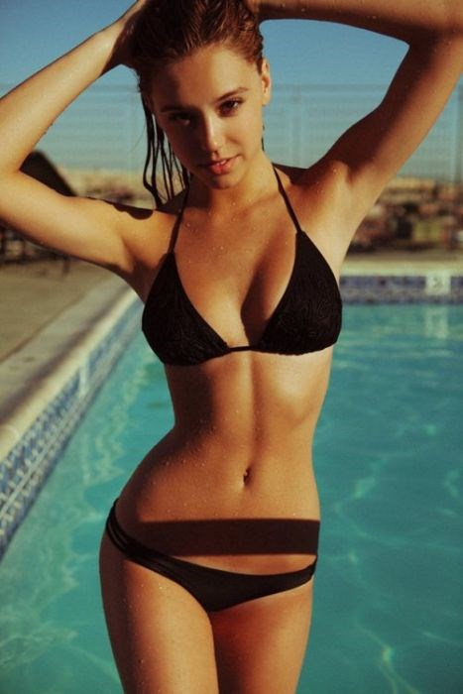
unsub now here

