Millions of pretty Babes
They Will Do Everything For You
They Will Show Every Part of Her Bodies
You can meet or chat by webcam!
NICK HERE - loretta6891428

VIEW NOW
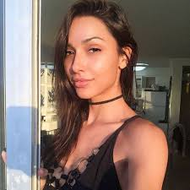
u-n-s-ubscribe

