I Would Like to Chat to Good Man
I'm pretty Slovenian Girl
Nick Name Is - francesca8851882

OPEN HERE NOW
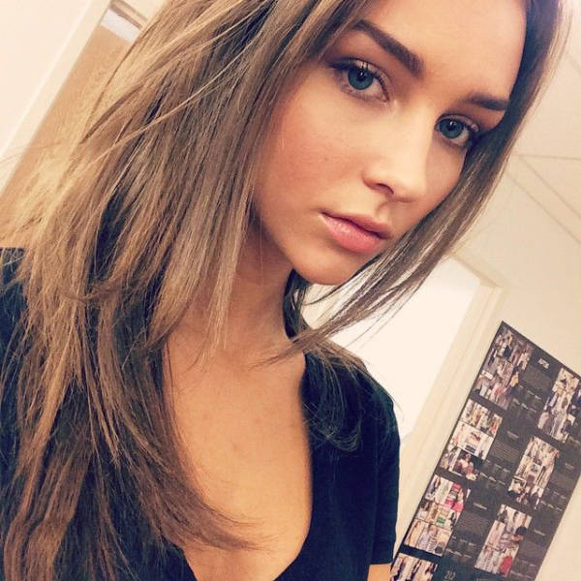
unsub here

