I Would Like to Chat to Good Man
I'm pretty Slovenian Girl
Nick Name Is - francesca4574248

CHECK IT NOW
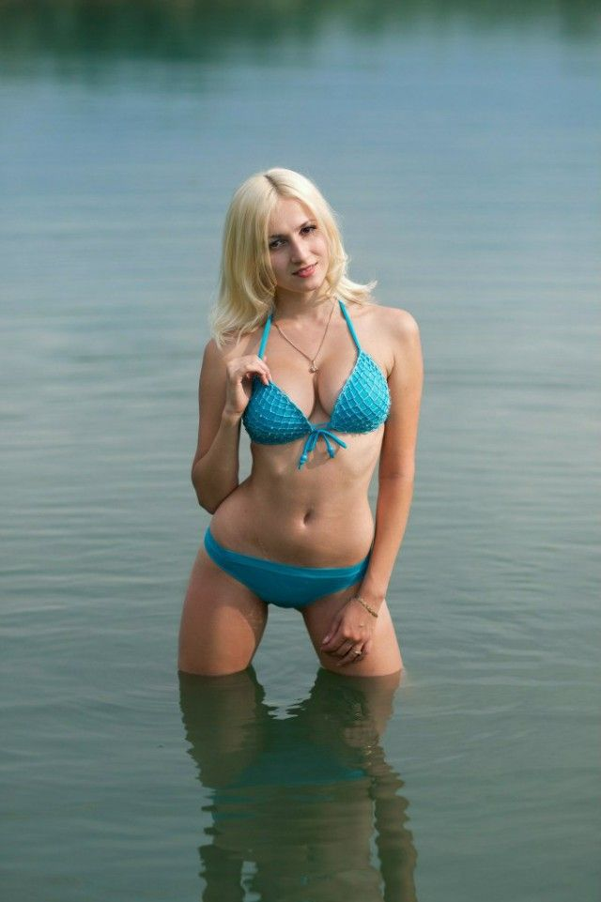
unsubscribe

