😍Here You Can Find Your Love😍
👅You Can Choose and Chat by Web-Cam or Meet👅
👄👄👄Everybody Wanna You Show All Body👄👄👄
My Nick - marta3285679

FIND HERE
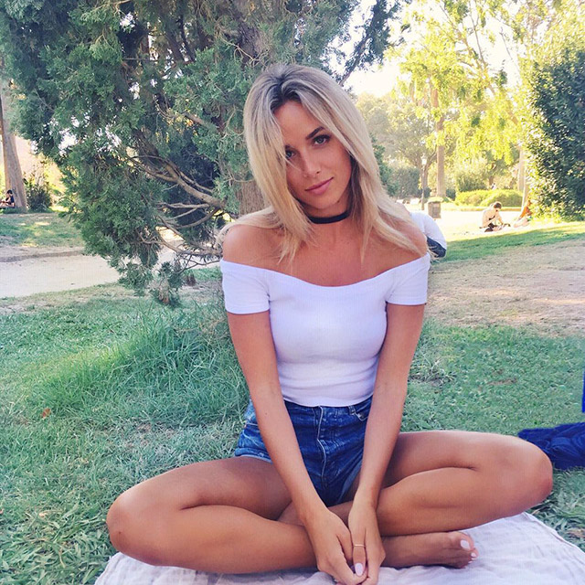
uns here

