Best Babes Ever
Wanna chat with beautie?
Than I was Made for You, Dear!
My Name on Portal: angelica1514521

OPEN HERE
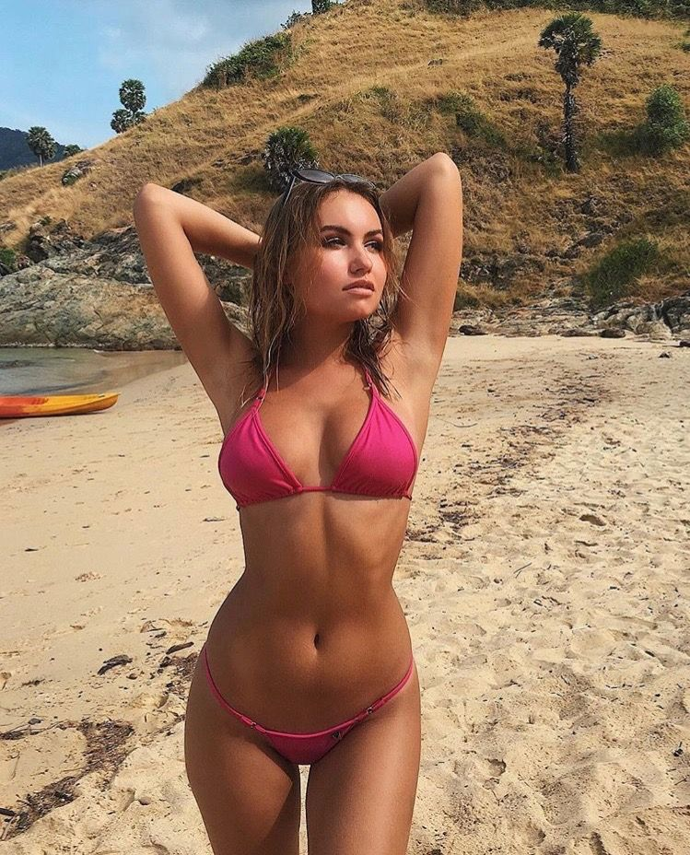
u-n-s-ubscribe

