MY CHAT HERE
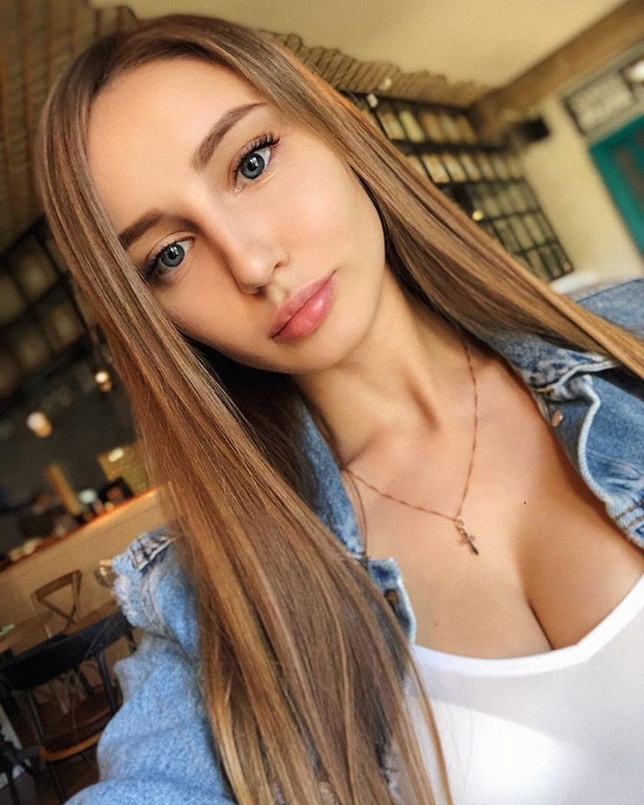

unsubscribe

