SEE MY PAGE
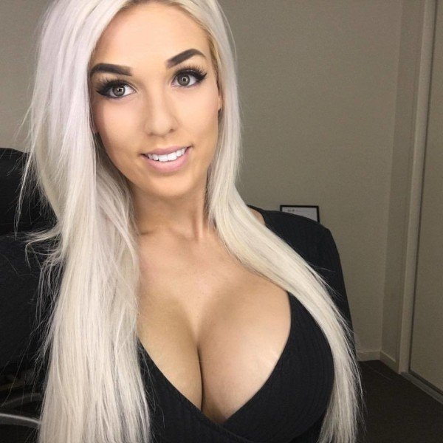

unsubscribe

