FIND ME NOW
My nick: juliabigboob19
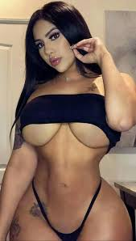

unsub

